Expanded Nuclear Disarmament Plank for 2016 “People’s Budget”

[From the People’s Budget National Coalition (v.1-31-16)].

1. Existing People’s Budget Policy with respect to nuclear weapons (from “The 2015 People’s Budget – A Raise for America “ page 12).

“Additional reforms include the decommissioning our Cold War-era nuclear weapons infrastructure, as outlined by the Smarter Approach to Nuclear Expenditures (SANE) Act, and reducing procurement and research, development, test, and evaluation (RDT&E) spending by making smarter procurement choices.”

2. Recommended Expanded Policy Statement for 2016 Peoples Budget Campaign guiding Nuclear Weapons portion of Peoples Budget:

“Increase National Security by Pursuing Nuclear Weapon Reductions, not Rearmament:

The long range security of the American people and indeed of the people of all nations depends on progress toward the elimination of nuclear weapons from the arsenals of all nations. As long as the weapons exist, dangers of intentional use, inadvertent use, or terrorist use, put the human and environmental ecosystem at risk.

The leading effort toward elimination of Nuclear Weapons is the Nuclear Non Proliferation Treaty, of which the US, Russia, China, Iran and more than 180 other nations are signatory to. Article 6 calls for all nations possessing nuclear weapons to move toward their elimination.

Sadly, the US is about to move in the opposite direction, with proposals to spend $hundreds of billions of taxpayer dollars to increase the destructiveness of our nuclear weapons arsenal. The People’s Budget calls for returning to the path of increased national security by avoiding such provocation, and continue to negotiate nuclear weapons reductions, as called for by President Obama and in the SANE legislation.

The current arsenal of US nuclear weapons includes more than 5,000 nuclear warheads carried by long range bombers, land-based intercontinental ballistic missiles, and Trident missiles launched from submarines. Some 2,000 of these are maintained launch-ready on hair trigger alert.

A single Ohio Class nuclear submarine can launch ~100 independently targeted megaton nuclear missiles, sufficient to obliterate the major cities of any nation on earth. The explosions of such warheads, could plunge the Earth into a Nuclear Winter, resulting in the death of hundreds of millions of people, including Americans. The Navy has 14 such submarines. In addition hundreds of warheads on bombs carried by long range bombers and silo-based missiles are on hair trigger alert. Keeping warheads on all three legs of the triad on hair-trigger alert sharply increases the danger of an inadvertent nuclear launch leading to accidental but still devastating nuclear exchange.
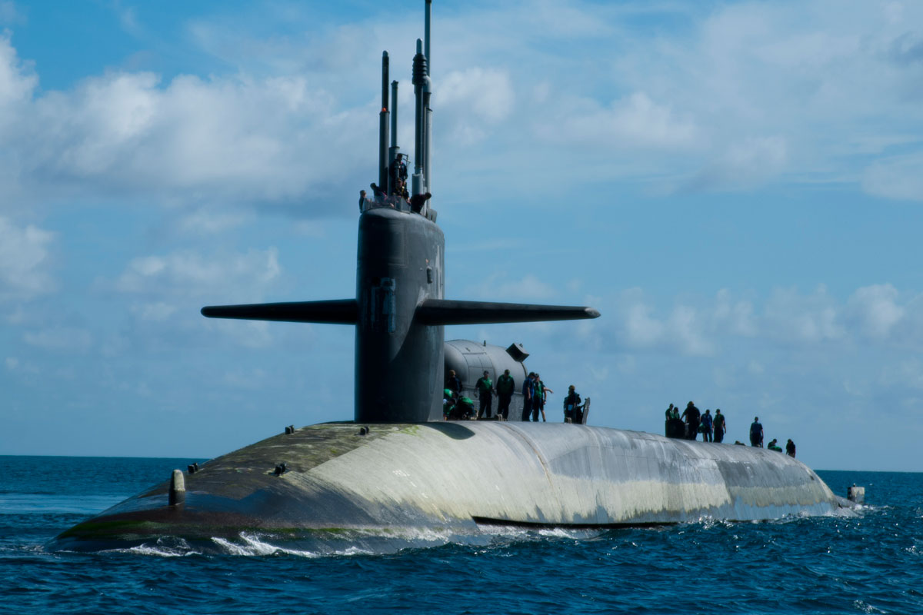The continued investment in and development of nuclear weapons increases the danger of nuclear war, and provides no solution to the problems of terrorism, mass migration, or international tension and instability. Increasing the destructive power of the US nuclear arsenal will make it increasingly difficult to convince other nations to forswear or limit their nuclear weapons,

The hundreds of billions of our tax dollars authorized for weapons contracts drain civilian budgets for housing, transportation, energy sufficiency, health care, veteran’s services and environmental protection.

The administration has proposed to upgrade the nuclear triad over the next few decades. According the Congressional Budget Office this will cost ~ 300 billion dollars over the next ten years. Upgrading of the nuclear weapons triad can only increase the threat felt by other nations, and in the end, decrease national security. In fact the costs are so large they threaten the Navy’s plan to maintain the conventional ships adequate for national defense.

The People’s Budget should at a minimum follow the proposals in Senate 8341, the “Smarter Approach to Nuclear Expenditures Act”, including reducing total nuclear warheads to ~1,000 following the spirit of the 2011 New Start Treaty with the Russian Federation.

This will entail reducing the number of nuclear-armed submarines operated by the Navy, prohibiting the Development of new long-range penetrating bombers, and prohibiting the development of new ballistic missiles.

Pursuit of nuclear arms and delivery systems “modernization” fuels an arms race that in the end makes us less, not more secure, as it diverts funds needed to address other sources of our insecurity, foremost, global warming, poverty, homelessness, disease, crumbling public infrastructure, decrepit school facilities and more.
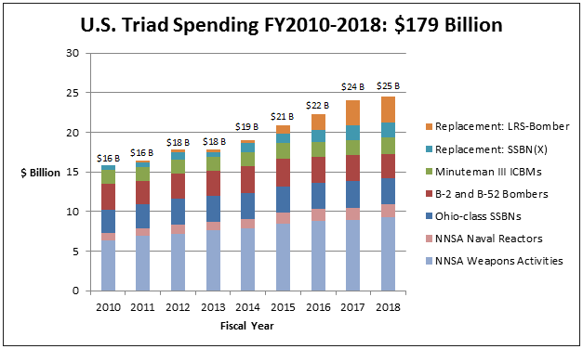
3) Peoples Budget Campaign Recommendations for cuts in Nuclear Weapons System Contracts based on principles outlined above:

A. With respect to the FY 2016 Omnibus Appropriations:

- Proposals in the FY2016 Omnibus bill to build 8 new nuclear armed submarines with upgraded missiles and warheads should be terminated.
  - Delete the $1.4 billion appropriated for 2017 nuclear-armed submarine development costs;
  - Delete $1.2 billion allocated for upgrading Trident II D-5 missiles;

- No funds shall be allocated for the development of new intercontinental ballistic missile, or air launched cruise missiles. Delete $75 million (new ICBM) + $16 million (new cruise missile).

- Defense from nuclear missiles is technically and militarily questionable, and destabilizes international treaty efforts.
  - The $1.3 billion for mid-course missile defense, and $8.1 billion authorized for the Missile Defense Agency should be sharply reduced by at least 75%..

- The Dept. of Energy budget includes about $18.8 billion for nuclear weapons development, maintenance, testing and other functions.
  - Some significant amount of these funds are to support the modernization of the nuclear triad (such as the “W78” and “W80” warhead programs) and should be deleted.
  - Unfortunately these funds are not explicitly identified in Congressional budget documents. The Dept. of Energy should be required to report to Congress on what fraction of their authorization is being used for upgrading nuclear weapons.

Total savings this coming year: At least $10 billion, not counting DOE cuts.

B. Nuclear Weapons Reductions over next ten years:

- Cancel modernization program for our nuclear arsenal:
- Cancel the Long Range Strike Bomber: savings ~$27 billion over 10 years;
- Cancel the new ballistic missile submarines: savings ~$33 billion over 10 years;
- Cancel procurement and R&D on ICBM upgrades: ~32 billion over 10 years;
- Cancel the air launched cruise missile: ~3 billion over 10 years;
- Scale back the B61 bomb life extension program: ~$4 billion over 10 years;

Savings over 10 years ~$100 billion.

Some Sources:

“The People’s Budget – A Raise for America “ Congressional Progressive Caucus, 2015. <http://cpcgrijalva.house.gov/uploads/FINAL%20FY16%20Peoples%20Budget.pdf>

The SANE Act, S. 831, 114th Congress.

“Omnibus Appropriations Analysis (updated): Including Nuclear Weapons Appropriations”. Council for A Livable World. December 17, 2015.

”Fighting for a U.S. federal budget that work for all Americans - Pentagon Budget Request FY2016, William French, National Priorities Project, June 4, 2015.

“The U.S. Nuclear Weapons Spending Binge”, Daryl Kimball, Arms Control today, December 2, 2015.

“Rearming for the Apocalypse” Stephen Kinzer, Boston Globe, Jan 4, 2016. https://www.bostonglobe.com/ideas/2016/01/24/beware-obama-nuclear-weapons-plan/IJP9E48w3cjLPlTqMhZdFL/story.html

Meet the Private Corporations building our Nuclear Arsenal, Richard Krushnic and Jonathan Alan King, The Nation, Sept. 22, 2015. http://www.thenation.com/article/meet-the-private-corporations-building-our-nuclear-arsenal/?nc=1

